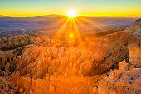
Robyn Bridges, M. Ed.
Eco-Soul Teacher, Author, and Inspirational Speaker

______________________________________________________________________

“Through conscious and active choice, we are healed and realigned through sacred mysteries and revealing powers inherent in the deep divine.”

-Robyn Bridges

