Works by Robyn Bridges: Poetry Collections

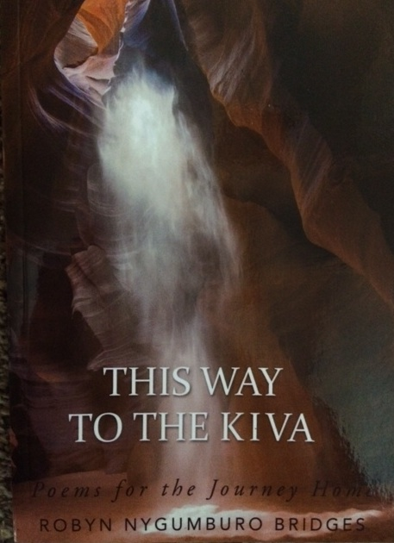

This Way to the Kiva: Poems for the Journey Home

Could the structure of ancient kivas in the American Southwest offer a template for the human interface of spirituality?

This Way to the Kiva chronicles our quest for meaning, solace, and support from the divine. Building upon Native American culture and teachings, the poems in this collection examine the human community and the natural world with profound insight, linking the individual’s urge for journey to the universal motion of the divine.

_________________________________________________________________________________________
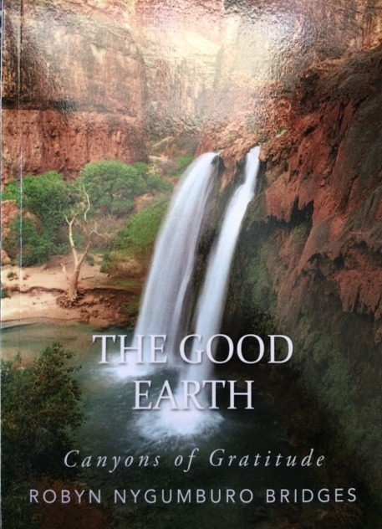
The Good Earth: Canyons of Gratitude

The earth pulses with a slow heartbeat, inviting us to quiet our own. Through time in nature, we downshift from busy days to spacious wisdom and from mental chatter to gracious sentience. The Good Earth offers refreshing reminders of the beauty of wild animals, rushing streams, and starlit nights. It returns us to visceral relief for our bodies and valued peace for our troubled minds. Gratitude then naturally bubbles up, and we revel in refreshed spirits.

The Good Earth encourages readers to rediscover how much they actually belong to nature, to others, and to themselves. This collection brings readers to the plains of Africa and the landscapes of Montana, to river songs and lake waters, meditating on nature’s cycling, the dance of the divine, and the urgency of our role within it all.
__________________________________________________________________________________________

Safe Passage: Eyes on Sunrise

Astute and insightful, the poems of Safe Passage examine the great adventure of exploring the heights and depths of answering the call of our own lives. Through these poems, we realize how to allow sorrow to transform into a life rich in soul. We become capable of hearing our own truth and discovering a heart full of self-compassion.

Safe Passage provides a template for navigating the unknown, by seeking safety within it and keeping eyes on sunrise. Through it all, we emerge with clear vision and a realized hope.
_______________________________________________________________________________
Uncharted Sorrows: The Incandescence of Loss
Uncharted Sorrows offers poems traversing both personal and collective heartache and loss. When we grieve, the territory is full of angst. Thwarted desire is a cruel taskmaster; limitation, loss, and death ultimately have their way. Though we rail at the injustice of dashed dreams, we heal by allowing ourselves to surrender to the alchemical mercy of a process beyond our grasp.

These poems seek to accompany any reader through his or her own dark times. Though one’s sorrows are one’s alone, others share the broader field of grieving with each individual. Readers will find comfort in this, while discovering a kind of holiness in the unexpected incandescence of their own grief.

